

The University of Azad Jammu and Kashmir, Muzaffarabad

Name | Jawahir Ali
Course Name | Computer Architecture and Logic Design
Submitted to | Engr. Sidra Rafique
Semester | 2nd
Session | 2024-2028
Roll No | 2024-SE-34
Lab No | 05

Department of Software Engineering

Half Adder Not
A B = Sum Carry
1 0 = 1 0
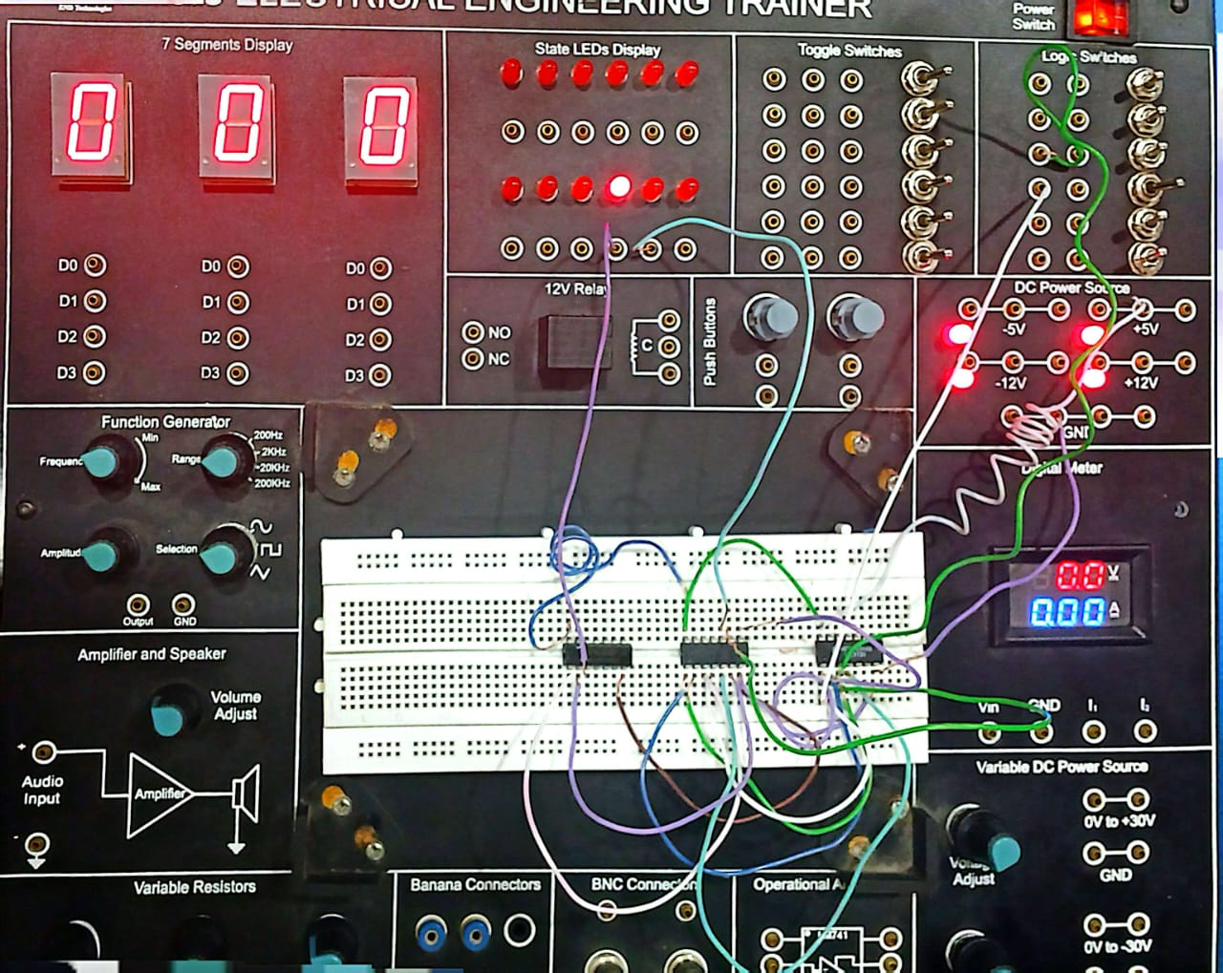
A B = Sum Carry
0 0 = 0 0
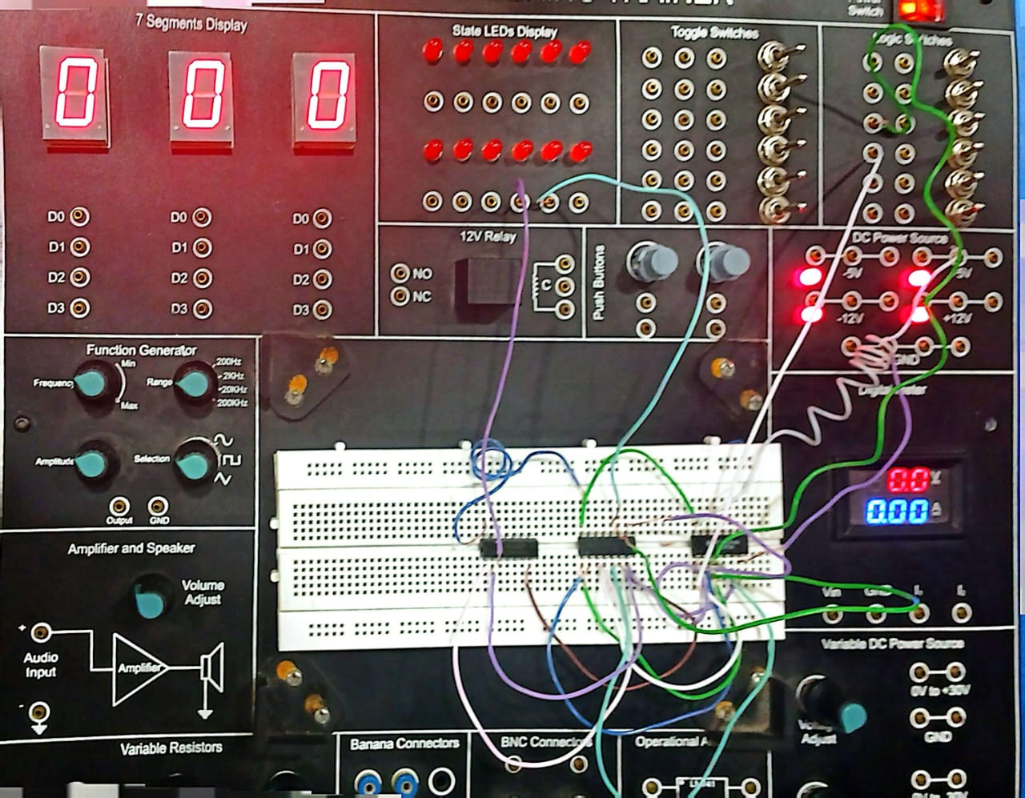
A B = Sum Carry
0 1 = 1 0
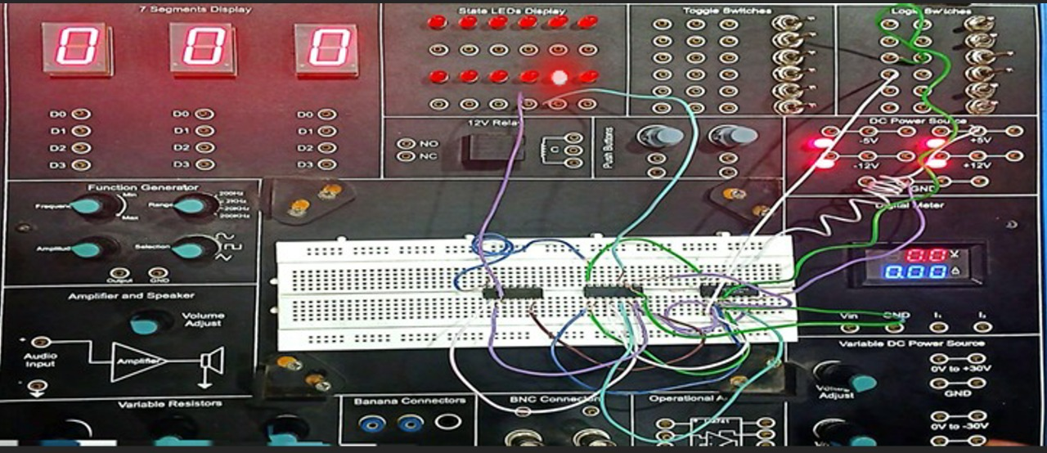
A B = Sum Carry
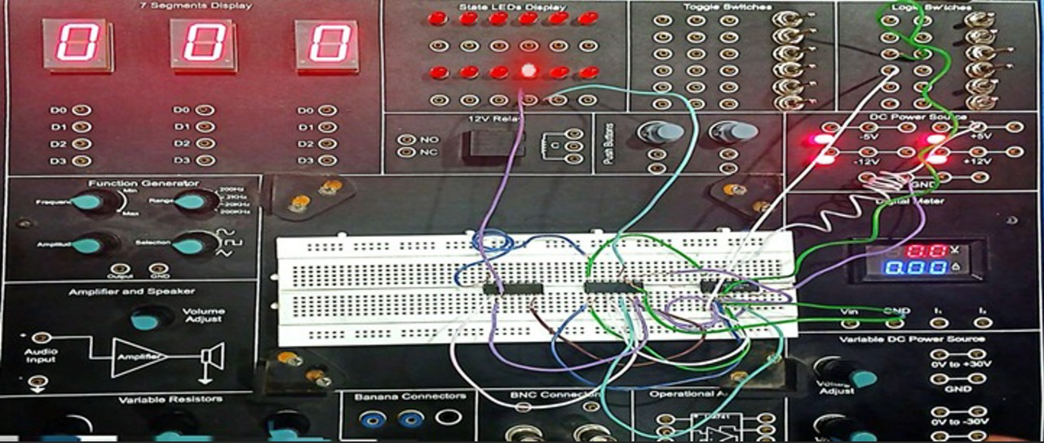 1 1 = 0 1

Half Adder X-OR
A B = Sum Carry
0 0 = 0 0
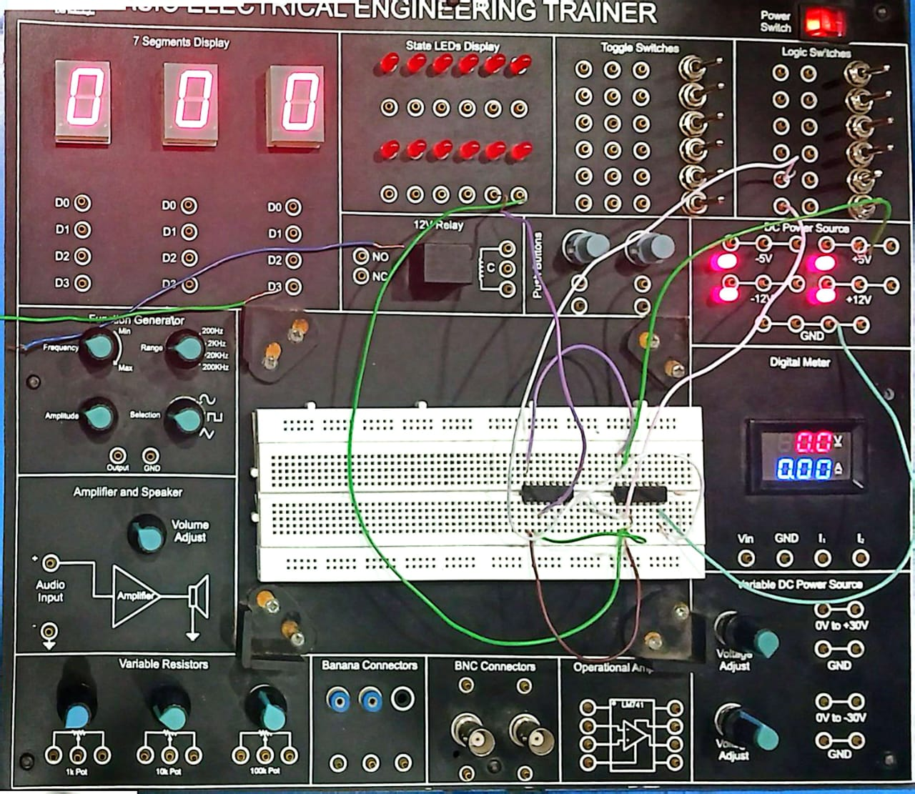
A B = Sum Carry
1 1 = 0 1
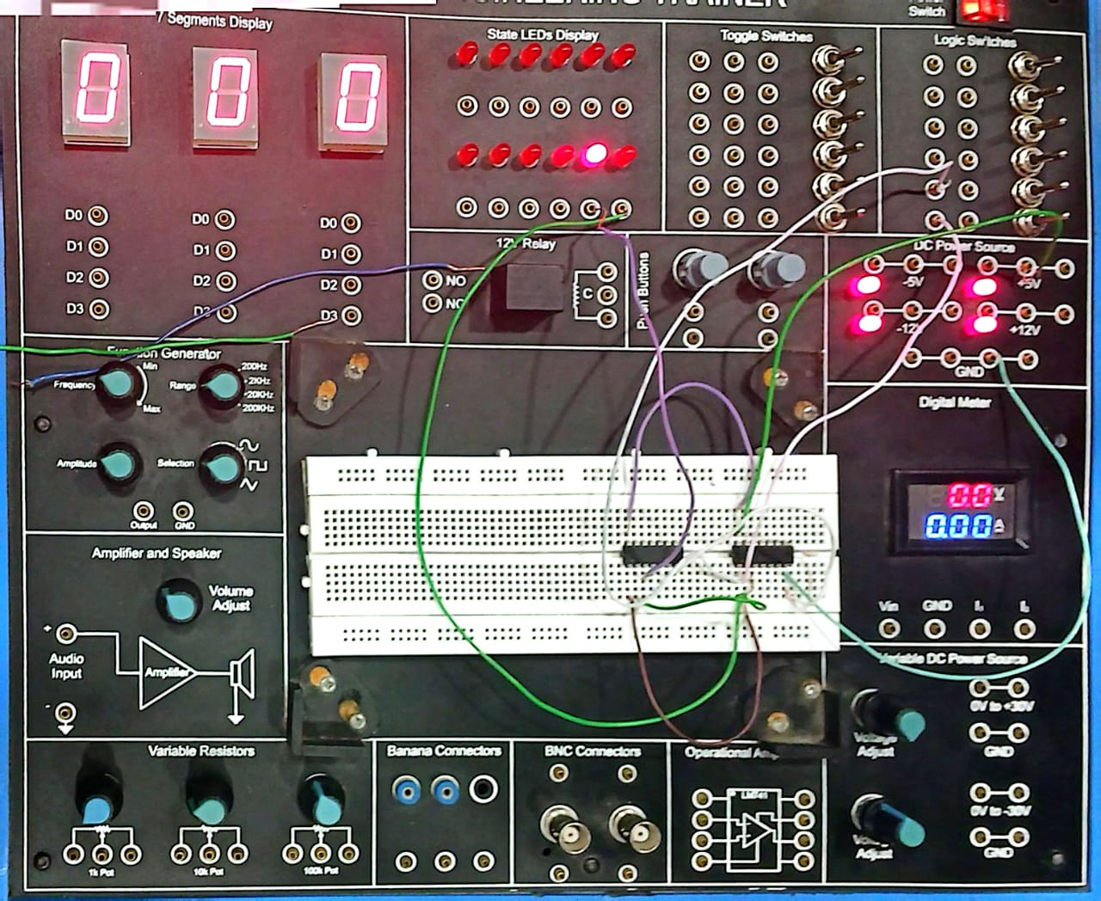
A B = Sum Carry
0 1 = 1 0
